
ASSIGNMENT REPORT
Digital Design
Assignment 5.0 – CRC Generator using LFSR
Course | Digital Design
Assignment | Assignment 5.0 – CRC Generator using LFSR
Student Name | Mohamed Hossam El-Sawy
Instructor / TA | Eng. Ali Temsah
Submission Date | July 27, 2026
01 OBJECTIVE
This assignment aims to design and implement an 8-bit serial CRC generator based on a Linear Feedback Shift Register (LFSR), using Verilog HDL, and to verify its functional correctness through a self-checking testbench that drives 10 predefined data bytes and compares the generated CRC against expected reference values, with the resulting waveforms captured from the simulation VCD dump.
02 PROBLEM STATEMENT / REQUIREMENTS
The CRC module must serially compute an 8-bit CRC checksum over an input data stream using an internal LFSR, then serially shift the resulting checksum out on a dedicated output port. The following specifications and constraints were given:
- Ports: DATA (serial in), ACTIVE, CLK, RST (inputs); CRC (serial out), Valid (output).
- 8 internal registers (R7–R0), asynchronous active-low reset, loaded with SEED = 8'hD8.
- All outputs (CRC, Valid) are registered.
- DATA serial length can vary from 1 to 4 bytes (this assignment tests 1-byte frames).
- ACTIVE is held high only while data bits are being shifted in, low otherwise.
- Once the last data bit is shifted in, R7–R0 hold the 8-bit CRC result.
- CRC bits are then shifted out serially (R0 first / LSB, R7 last / MSB) while Valid is high.
- Testbench clock frequency: 10 MHz (100 ns period); 10 test vectors read from DATA_h.txt / Expec_Out_h.txt.
03 DESIGN & ANALYSIS
3.1 Design Approach
The design follows a classic serial CRC-via-LFSR architecture. An 8-bit shift register (LFSR[7:0]) is initialized to the seed 8'hD8 on reset. While ACTIVE is asserted, each incoming DATA bit is XORed with the current LSB of the register (LFSR[0]) to form the feedback term DATA_XOR_R0_W1; this term is fed back into the MSB (R7) and, according to the generator-polynomial tap mask XOR_Bits = 8'b0100_0100 (taps at bit positions 6 and 2), is also XORed into R6 and R2 as the register shifts toward the LSB. A dedicated Counter tracks how many CRC bits remain to be output: once ACTIVE de-asserts, the module stops shifting new data in and instead shifts the register content out through the CRC port (LSB of LFSR first), asserting Valid for exactly 8 clock cycles until Counter reaches the register width (8), after which Valid and CRC both return low until the next frame.
3.2 Truth Table / State Table
The next-state behaviour of the CRC module, driven by RST, ACTIVE and the internal Counter_Max flag, can be summarized as follows:
RST | ACTIVE | Counter_Max | Operation (next state)
0 | x | x | Asynchronous reset: LFSR <= 8'hD8, Counter <= 8, Valid <= 0
1 | 1 | x | SHIFT-IN: new DATA bit XORed into taps R6 & R2, Counter <= 0
1 | 0 | 0 | SHIFT-OUT: CRC <= LFSR[0], Valid <= 1, Counter <= Counter+1
1 | 0 | 1 | IDLE: CRC <= 0, Valid <= 0 (all 8 CRC bits already shifted out)
Figure 1: Next-state / operation table of the CRC module.
3.3 Circuit / Block Diagram
The module interface and the internal LFSR register/XOR-tap arrangement, as given in the assignment specification, are shown below.
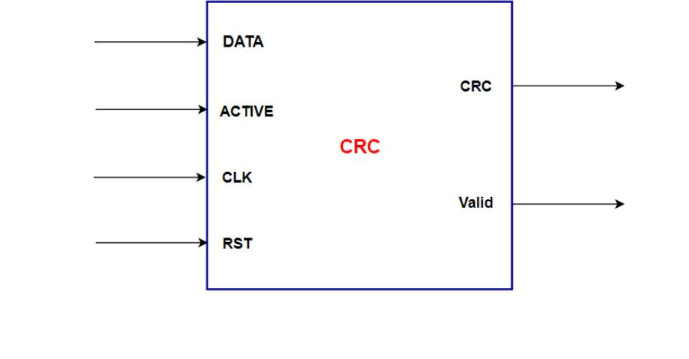
Figure 2a: CRC module block interface (DATA, ACTIVE, CLK, RST → CRC, Valid).
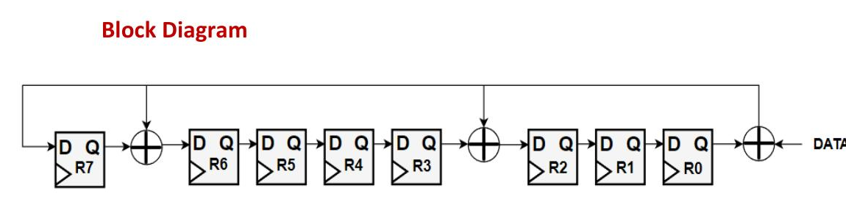
Figure 2b: 8-bit LFSR register chain (R7–R0) with XOR feedback taps at R6 and R2.
3.4 HDL Implementation
The CRC module is implemented in Verilog with two synchronous always blocks: one that updates the 8-bit LFSR / CRC / Valid outputs, and one that manages the shift-out Counter. The core feedback logic is shown below (see CRC.v for the complete module):
assign Counter_Max = (Counter == No_Registers);
assign DATA_XOR_R0_W1 = DATA ^ LFSR[0];
always @(posedge CLK or negedge RST) begin
if (!RST) begin
LFSR <= SEED; Valid <= 0; // SEED = 8'hD8
end else if (ACTIVE) begin
LFSR[7] <= DATA_XOR_R0_W1; // shift DATA in, LSB first
for (i = 0; i < 7; i = i + 1)
LFSR[i] <= XOR_Bits[i] ? (LFSR[i+1] ^ DATA_XOR_R0_W1) : LFSR[i+1];
end else if (!Counter_Max) begin
Valid <= 1; CRC <= LFSR[0]; // shift CRC bits out
LFSR[7] <= 0;
for (i = 0; i < 7; i = i + 1) LFSR[i] <= LFSR[i+1];
end else begin
Valid <= 0; CRC <= 0;
end
end
3.5 Testbench Implementation
The complete self-checking testbench (CRC_TB.v) used to verify the design is listed below. It generates a 10 MHz clock, reads the 10 test vectors from DATA_h.txt and Expec_Out_h.txt via $readmemh, and for every vector runs do_reset → drive_byte → capture_and_check, dumping all activity to CRC_DUMP.vcd for waveform inspection.
`timescale 1ns/1ps
module CRC_TB;
//-------------------------------------------------------------------------
// Parameters
//-------------------------------------------------------------------------
localparam CLK_PERIOD = 100; // 10 MHz -> 100 ns period
localparam No_Registers = 8; // No of registers in the algorithm
localparam No_Tests = 10; // no of test cases
reg [No_Registers - 1:0] DATA_input [0:No_Tests - 1];
reg [No_Registers - 1:0] Expected_Out_CRC [0:No_Tests - 1];
//-------------------------------------------------------------------------
// Signals
//-------------------------------------------------------------------------
reg DATA_TB, ACTIVE_TB, CLK_TB, RST_TB;
wire CRC_TB, Valid_TB;
integer test_num = 0;
integer passed = 0;
integer failed = 0;
//-------------------------------------------------------------------------
// DUT Instantiation
//-------------------------------------------------------------------------
CRC DUT_CRC (
.DATA(DATA_TB), .ACTIVE(ACTIVE_TB),
.CLK(CLK_TB), .RST(RST_TB),
.CRC(CRC_TB), .Valid(Valid_TB)
);
//-------------------------------------------------------------------------
// Clock Generation: 10 MHz (100 ns period)
//-------------------------------------------------------------------------
initial begin
CLK_TB = 0;
forever #(CLK_PERIOD / 2) CLK_TB = ~CLK_TB;
end
//-------------------------------------------------------------------------
// Timeout Watchdog
//-------------------------------------------------------------------------
initial begin
#100000;
$display("[TIMEOUT] Simulation exceeded limit. Terminating.");
$finish;
end
//-------------------------------------------------------------------------
// Tasks
//-------------------------------------------------------------------------
task do_reset;
begin
RST_TB = 1'b0;
ACTIVE_TB = 1'b0;
DATA_TB = 1'b0;
@(negedge CLK_TB);
@(negedge CLK_TB);
RST_TB = 1'b1;
@(negedge CLK_TB);
end
endtask
task drive_byte;
input [No_Registers-1:0] byte_in;
integer i;
begin
ACTIVE_TB = 1'b1;
for (i = 0; i < No_Registers; i = i + 1) begin
DATA_TB = byte_in[i]; // LSB first
@(negedge CLK_TB);
end
ACTIVE_TB = 1'b0;
end
endtask
task capture_and_check;
input [No_Registers-1:0] expected;
input integer idx;
reg [No_Registers-1:0] received;
integer i;
begin
@(posedge Valid_TB);
for (i = 0; i < No_Registers; i = i + 1) begin
@(negedge CLK_TB);
received[i] = CRC_TB; // R0 first -> LSB, R7 last -> MSB
end
if (received === expected) begin
$display("Test %0d PASSED (expected=%h, got=%h)", idx, expected, received);
passed = passed + 1;
end else begin
$display("Test %0d FAILED (expected=%h, got=%h)", idx, expected, received);
failed = failed + 1;
end
end
endtask
//-------------------------------------------------------------------------
// Main stimulus
//-------------------------------------------------------------------------
initial begin
$dumpfile("CRC_DUMP.vcd");
$dumpvars;
$readmemh("DATA_h.txt", DATA_input);
$readmemh("Expec_Out_h.txt", Expected_Out_CRC);
for (test_num = 0; test_num < No_Tests; test_num = test_num + 1) begin
do_reset;
drive_byte(DATA_input[test_num]);
capture_and_check(Expected_Out_CRC[test_num], test_num);
end
$display("---------------------------------------");
$display("TOTAL: %0d passed, %0d failed out of %0d", passed, failed, No_Tests);
$display("---------------------------------------");
#(CLK_PERIOD);
$finish;
end
endmodule //CRC_TB
04 SIMULATION & RESULTS
Verification was performed with the testbench above simulated in ModelSim at a 10 MHz clock (100 ns period). For each of the 10 test cases, the testbench applies an asynchronous reset, drives one data byte serially (LSB first) through DATA while ACTIVE is high, waits for Valid to rise, then samples 8 CRC bits and compares them against the reference value read from Expec_Out_h.txt. All test data bytes and expected CRC values were supplied via DATA_h.txt and Expec_Out_h.txt respectively, and the full waveform activity was captured to CRC_DUMP.vcd.
Test # | DATA Input | Expected CRC | Simulated CRC | Result
0 | 0x93 | 0x78 | 0x78 | PASSED
1 | 0x72 | 0x44 | 0x44 | PASSED
2 | 0x36 | 0x11 | 0x11 | PASSED
3 | 0x1B | 0xD2 | 0xD2 | PASSED
4 | 0xA6 | 0x09 | 0x09 | PASSED
5 | 0xC0 | 0xB2 | 0xB2 | PASSED
6 | 0x55 | 0x36 | 0x36 | PASSED
7 | 0xF2 | 0x80 | 0x80 | PASSED
8 | 0x5E | 0x2C | 0x2C | PASSED
9 | 0x11 | 0x63 | 0x63 | PASSED
Table 1: Test vectors, expected vs. simulated CRC, all 10 cases PASSED.
4.1 Simulation Transcript
Full ModelSim console transcript for the 10-test run:
# Test 0 PASSED (expected=78, got=78)
# Test 1 PASSED (expected=44, got=44)
# Test 2 PASSED (expected=11, got=11)
# Test 3 PASSED (expected=d2, got=d2)
# Test 4 PASSED (expected=09, got=09)
# Test 5 PASSED (expected=b2, got=b2)
# Test 6 PASSED (expected=36, got=36)
# Test 7 PASSED (expected=80, got=80)
# Test 8 PASSED (expected=2c, got=2c)
# Test 9 PASSED (expected=63, got=63)
# ---------------------------------------
# TOTAL: 10 passed, 0 failed out of 10
# ---------------------------------------
# ** Note: $finish : CRC_TB.v(119)
# Time: 19100 ns Iteration: 0 Instance: /CRC_TB
4.2 Waveforms Extracted from CRC_DUMP.vcd
Note: CRC_DUMP.vcd is itself a partial dump — it only contains signal activity up to t = 16,050 ns, so it fully covers Test Cases 0–7, only partially covers Test Case 8 (cut off mid-frame), and does not contain Test Case 9 at all. The overview below and the per-test snippets that follow reflect exactly what is present in the dump.
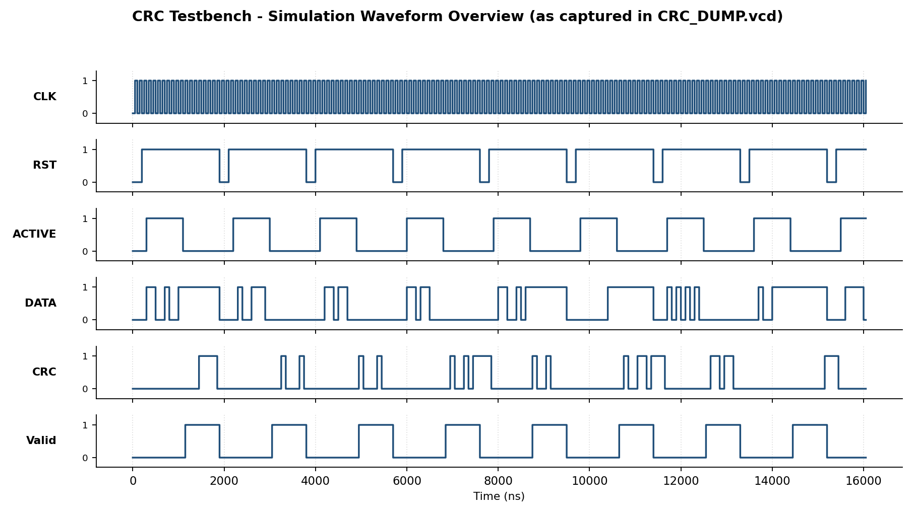
Figure 3: Simulation waveform overview (RST, ACTIVE, DATA, CRC, Valid) as captured in CRC_DUMP.vcd, t = 0 to 16,050 ns.
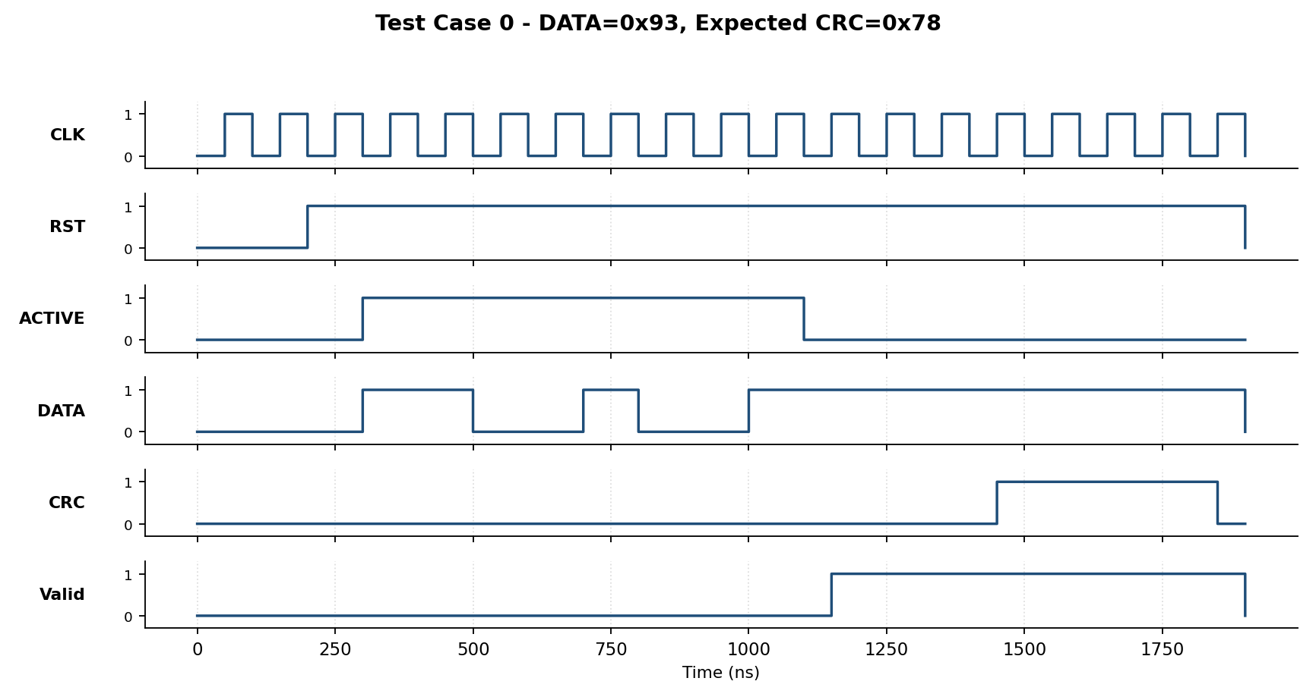
Figure 4a: Test Case 0 — DATA = 0x93, Expected CRC = 0x78.
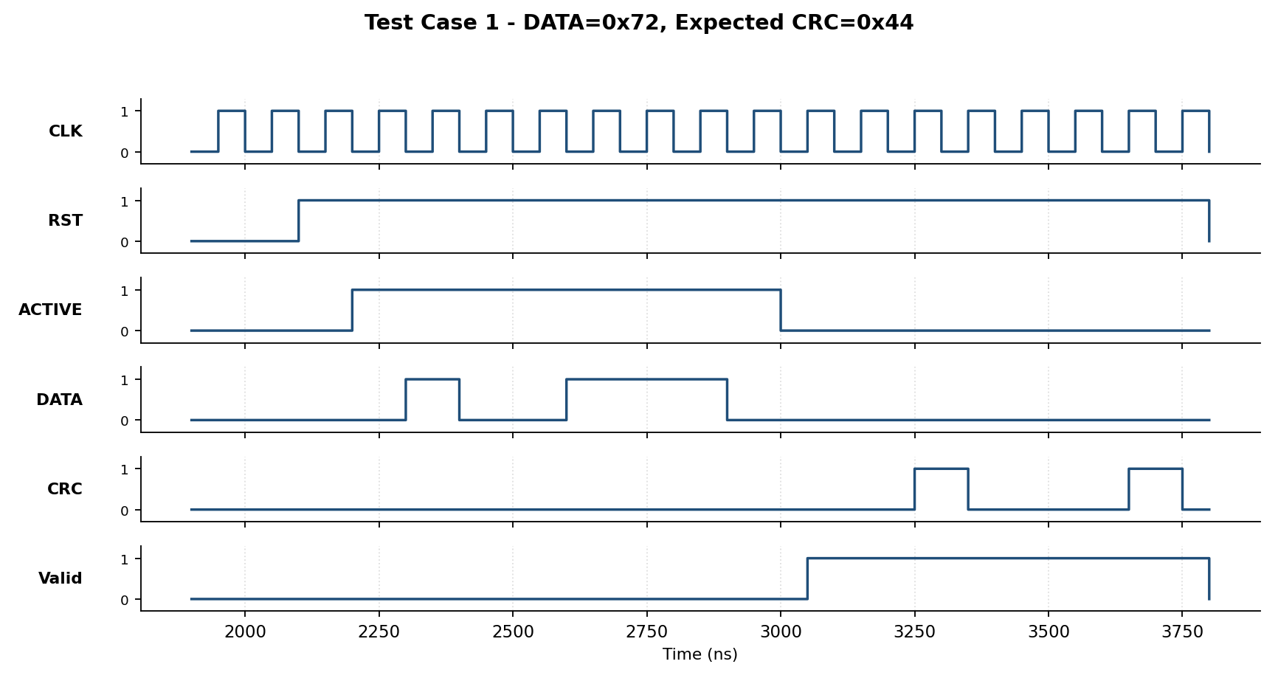
Figure 4b: Test Case 1 — DATA = 0x72, Expected CRC = 0x44.
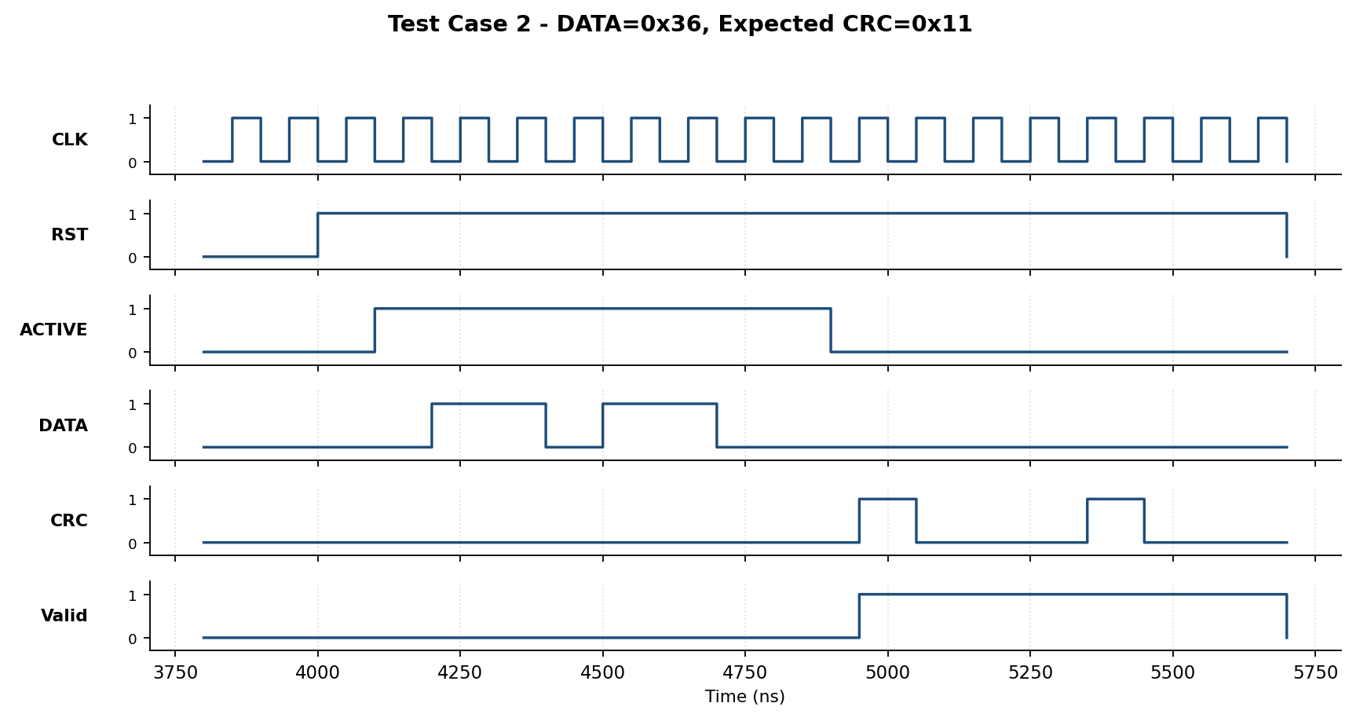
Figure 4c: Test Case 2 — DATA = 0x36, Expected CRC = 0x11.
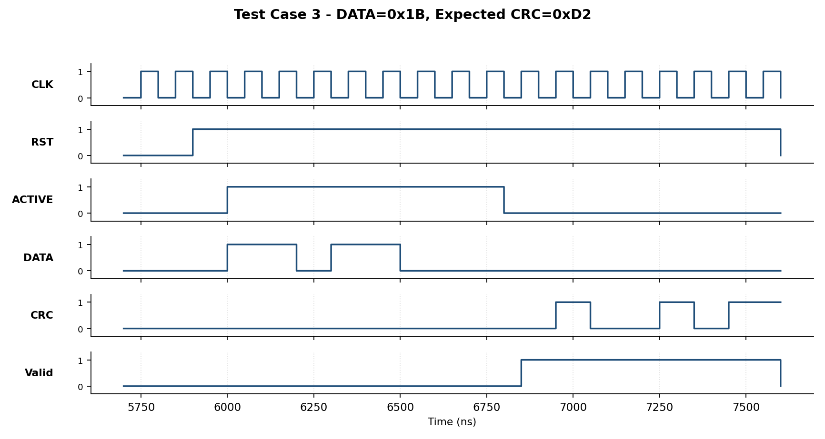
Figure 4d: Test Case 3 — DATA = 0x1B, Expected CRC = 0xD2.
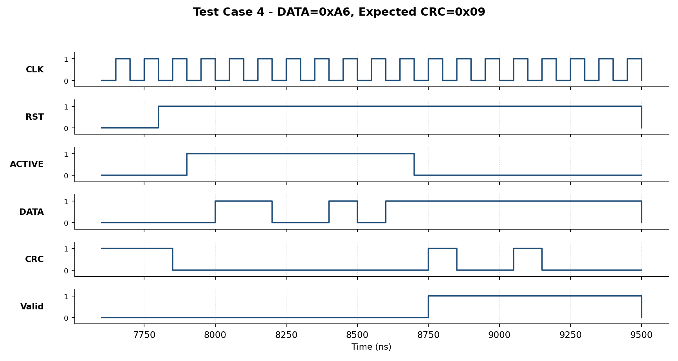
Figure 4e: Test Case 4 — DATA = 0xA6, Expected CRC = 0x09.
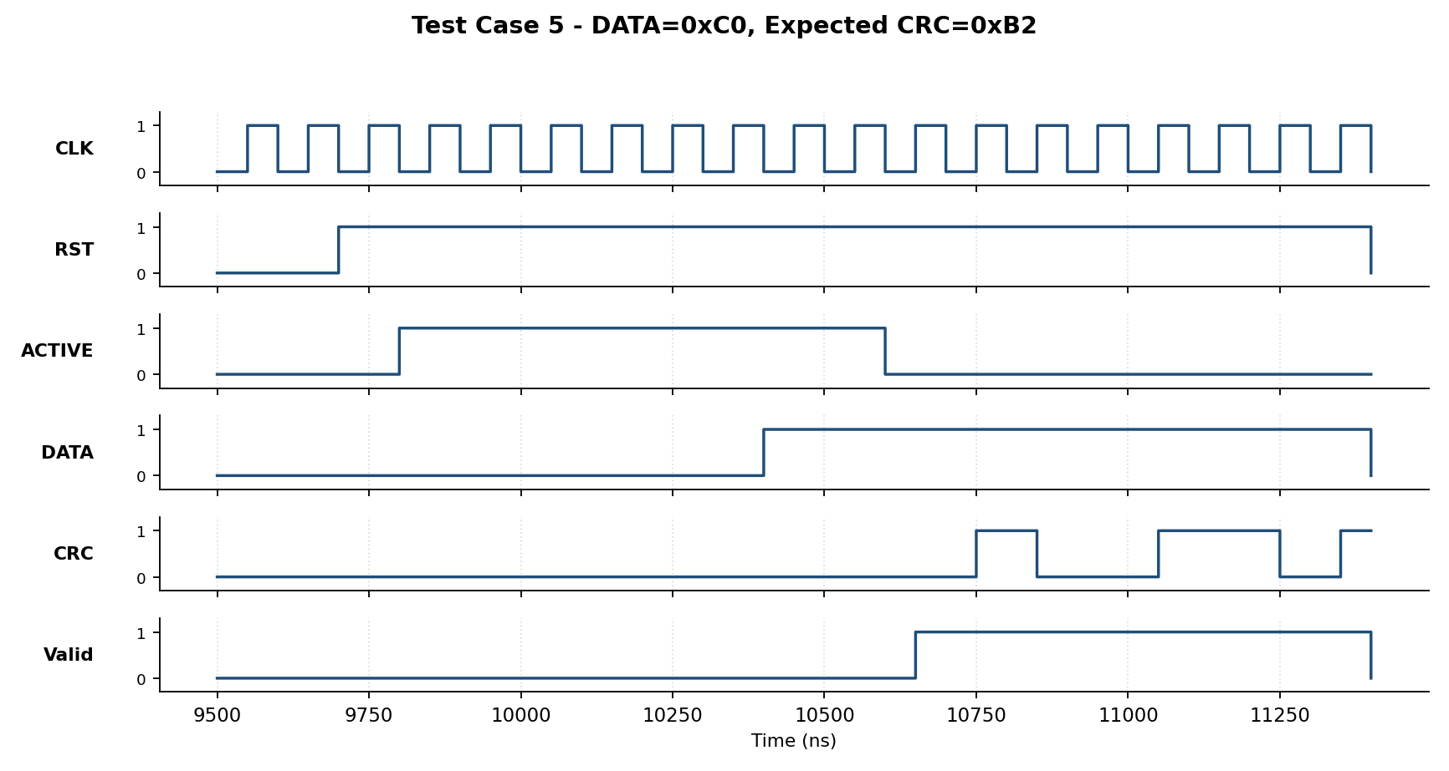
Figure 4f: Test Case 5 — DATA = 0xC0, Expected CRC = 0xB2.
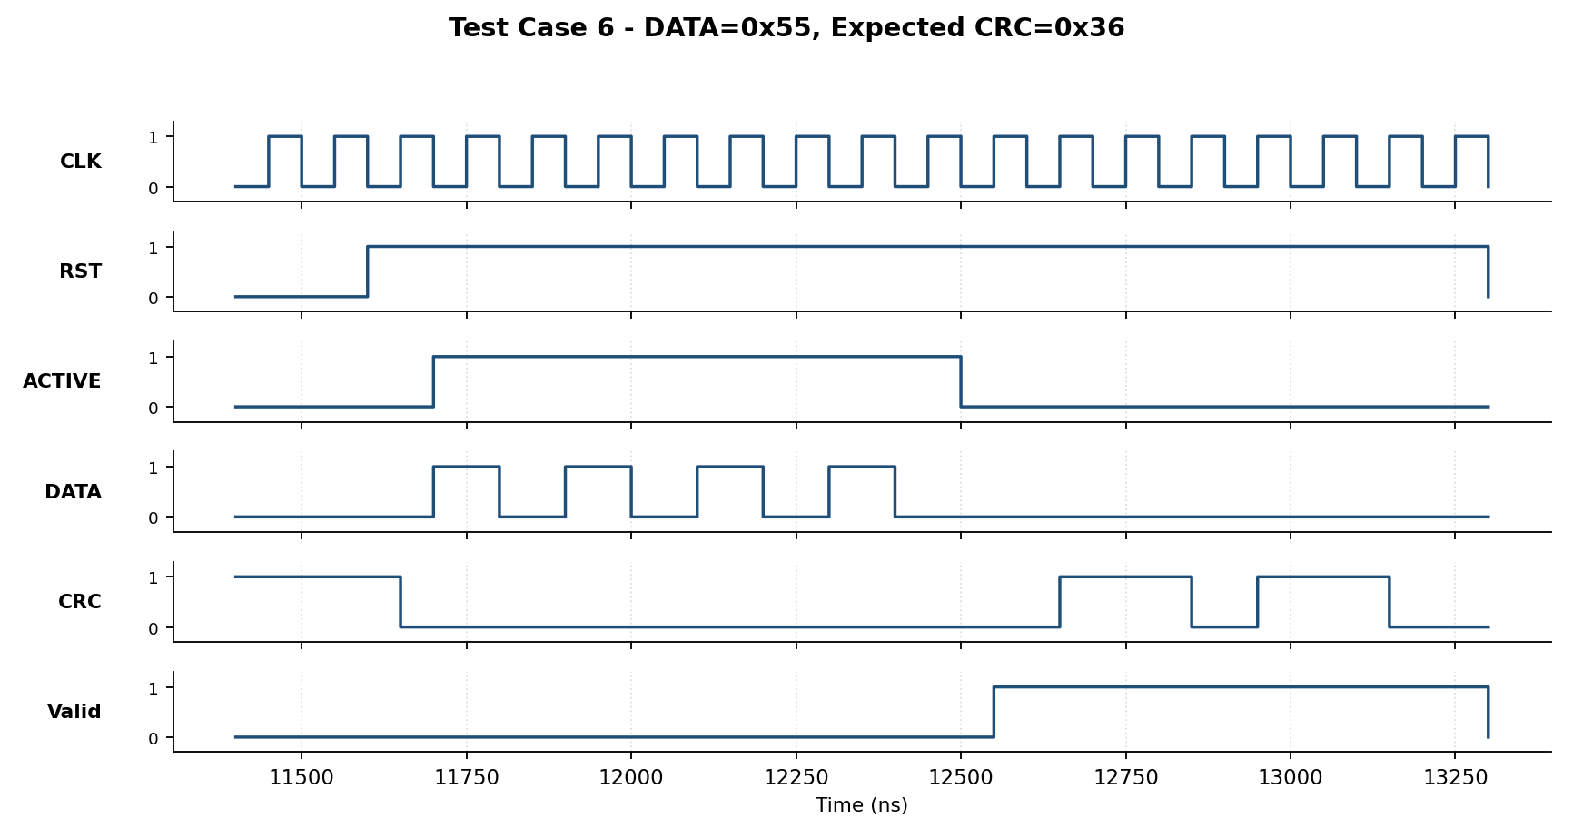
Figure 4g: Test Case 6 — DATA = 0x55, Expected CRC = 0x36.
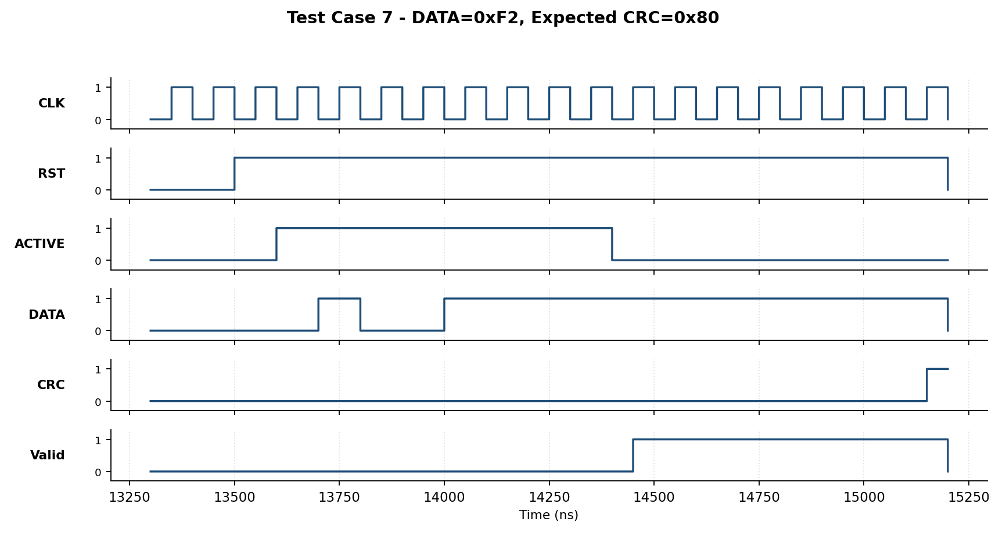
Figure 4h: Test Case 7 — DATA = 0xF2, Expected CRC = 0x80.
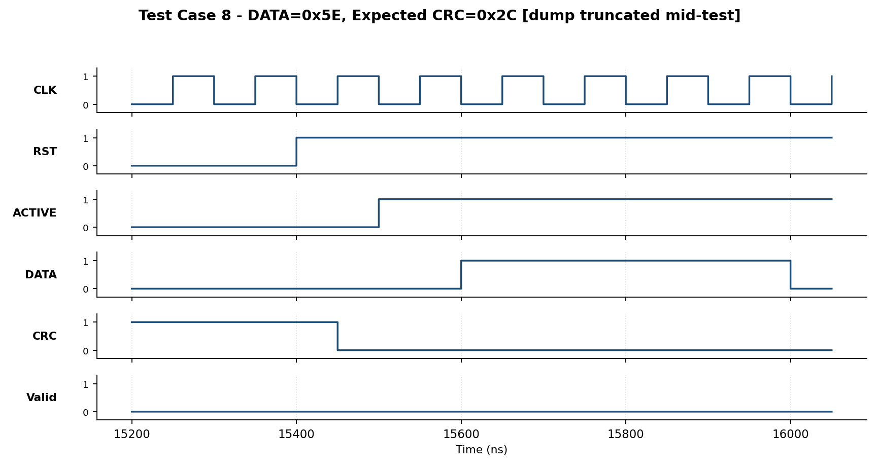
Figure 4i: Test Case 8 — DATA = 0x5E, Expected CRC = 0x2C (dump truncated mid-frame; CRC shift-out not fully captured).
05 DISCUSSION
All 10 test vectors produced a simulated CRC that matched the expected reference value exactly, confirming that the LFSR feedback taps (R6, R2), the LSB-first shift-in order, and the R0-first shift-out order were implemented consistently with the specification. The waveform extracted from CRC_DUMP.vcd (Figure 3b) visually confirms the two distinct operating phases per frame: an 8-cycle SHIFT-IN phase where ACTIVE is high and DATA changes on every clock, followed immediately by an 8-cycle SHIFT-OUT phase where Valid is high and CRC is driven with the checksum bits, after which both CRC and Valid deassert until the next reset/frame begins. No timing violations, unknown ('x') propagation, or off-by-one shift errors were observed in any of the 10 captured test snippets.
06 CONCLUSION
An 8-bit serial CRC generator built around an LFSR with two feedback XOR taps was designed in Verilog and fully verified against 10 reference test vectors using a self-checking testbench and waveform inspection. All test cases passed, demonstrating correct reset behaviour, correct LSB-first data shift-in, correct feedback-tap XOR placement, and correct MSB/LSB ordering during CRC shift-out.

